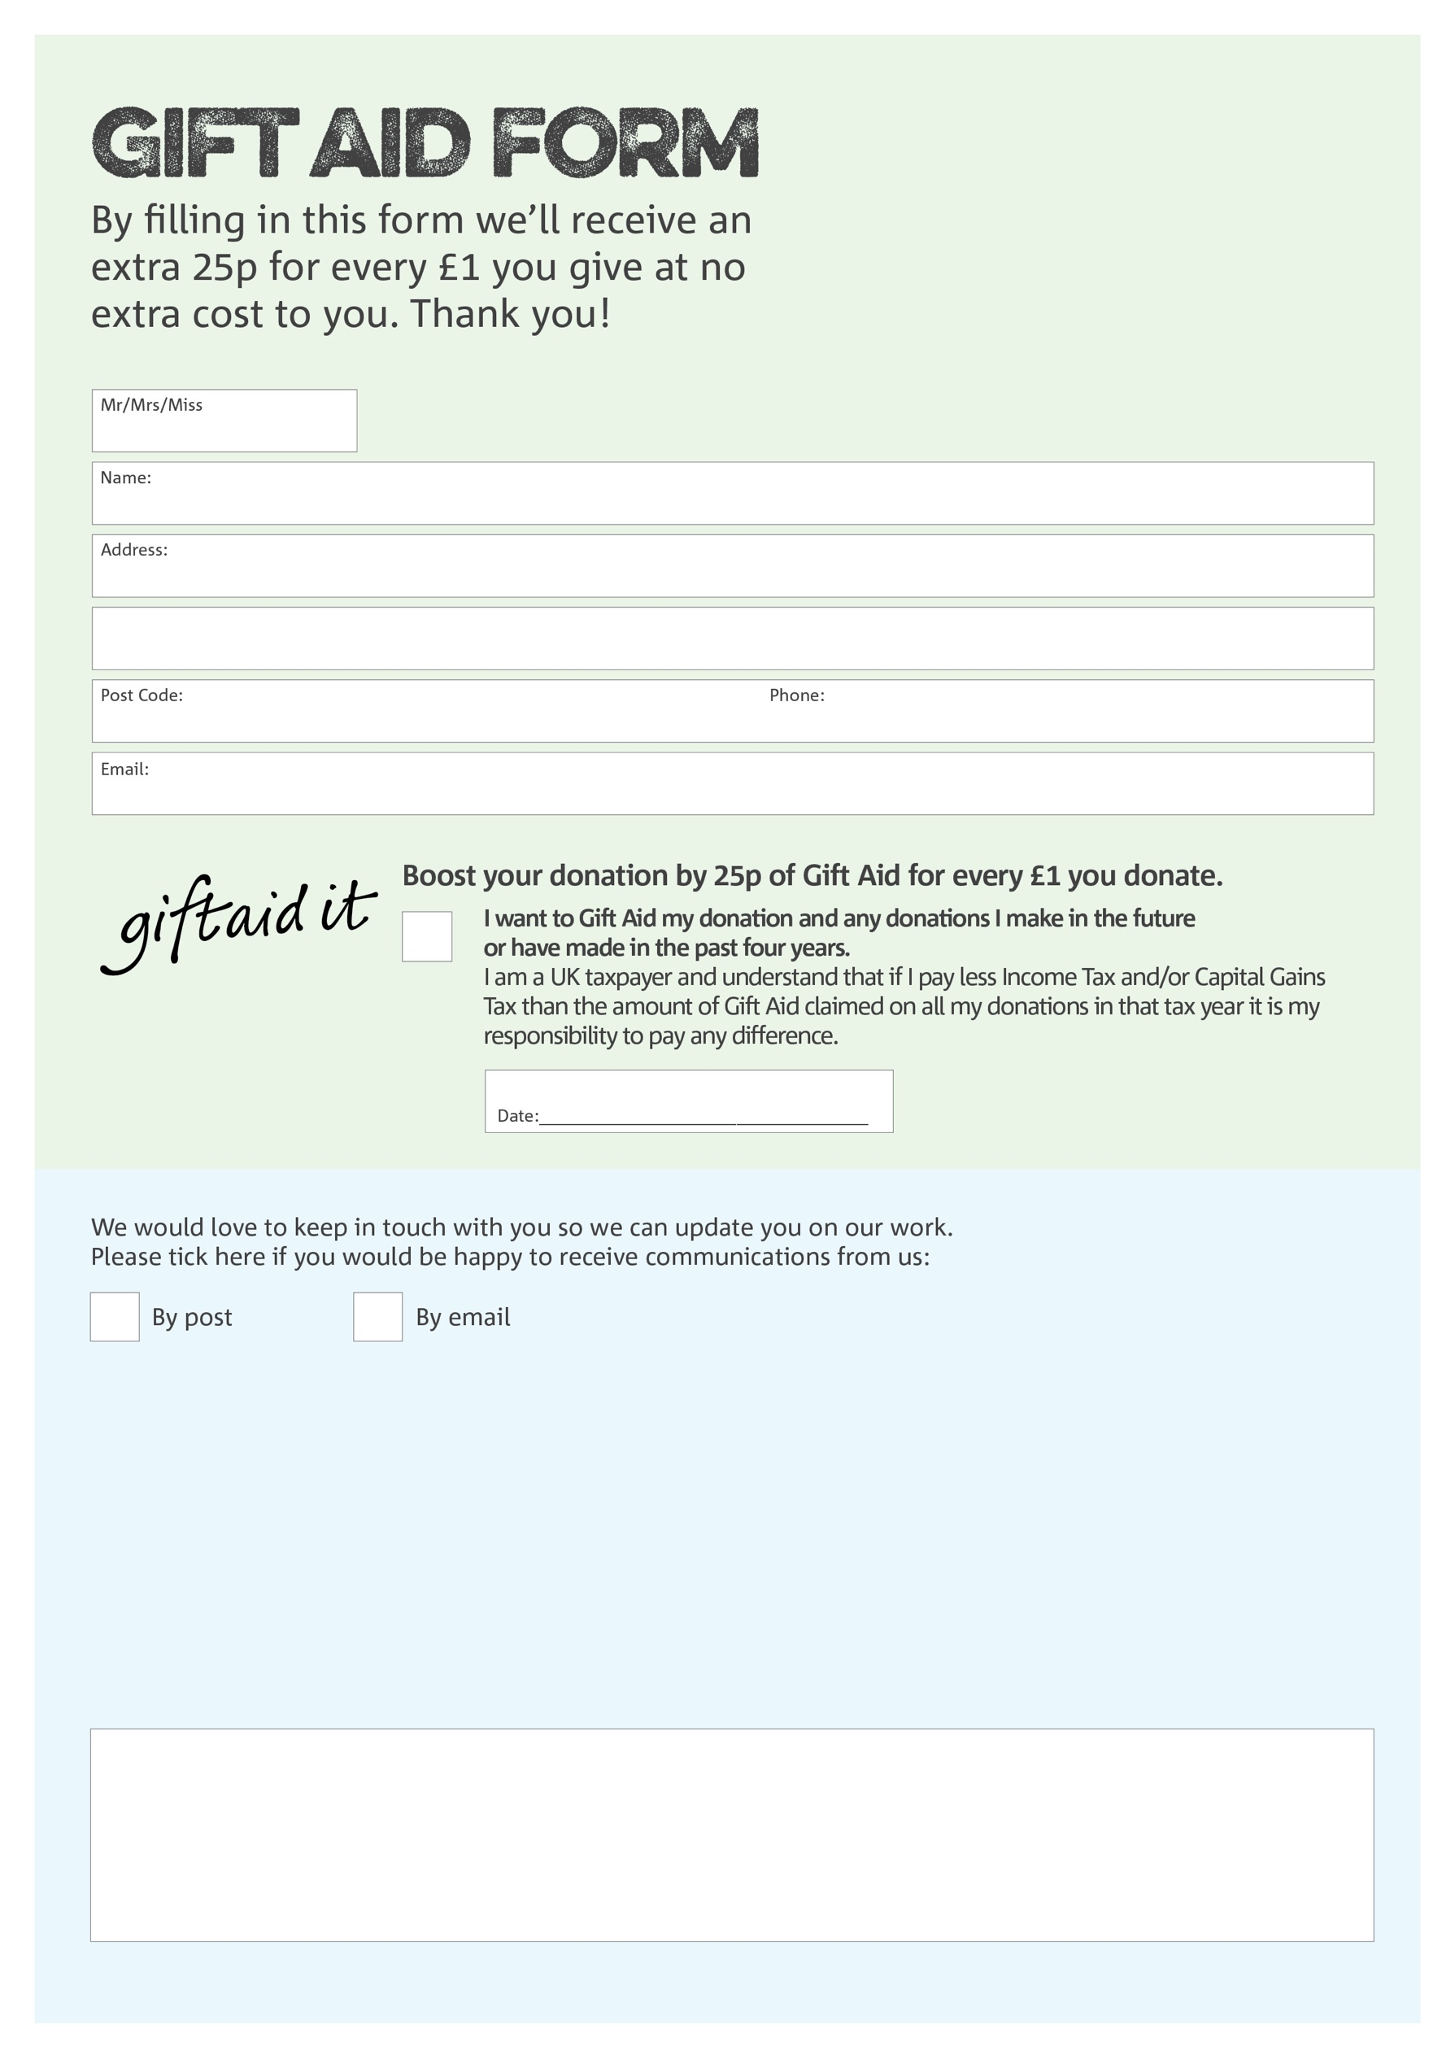

You can change your preferences any time by contacting us on 07964 690323 or emailing us at [info@edenbridge.foodbank.org.uk](mailto:info@edenbridge.foodbank.org.uk)

Please send this form by email to [info@edenbridge.foodbank.org.uk](mailto:info@edenbridge.foodbank.org.uk) or by post to Edenbridge Foodbank, 76 Hever Road, Edenbridge, Kent, TN 8 5DJ

**Data protection**

Edenbridge Foodbank is committed to protecting your privacy and will process your personal data in accordance with the current Data Protection legislation. Edenbridge Foodbank collects information to keep in touch with you and supply you with information relating to our work. Edenbridge Foodbank will never sell or pass your details to anyone who isn’t directly working on our behalf.

We would love to know why you have chosen to donate to Edenbridge Foodbank. If you would like to share your motivation let us know below:

Charity Number 1181051Registered in England and Wales